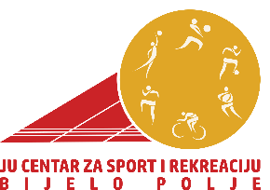
Ul. Nedeljka Merdovića br. 13,
84000 Bijelo Polje
Tel: 050/484-633,email: sport@bijelopolje.co.me

PRIJAVNI OBRAZAC ZA UČEŠĆE NA 2. SEMINARU “FIZIČKA PRIPREMA SPORTISTA”BIJELO POLJE

DATUM ODRŽAVANJA SEMINARA: 27.11.2021. GODINE
MJESTO I VRIJEME ODRŽAVANJA SEMINARA:
- HOTEL FRANCA “CENTAR” – KOFERENCIJSKA SALA 10H – 14H;
- DVORANA “NIKOLJAC” 18H – 20H;

*Ime i prezime:________________________________________________________________

*Broj telefona:_________________________________________________________________
*email:_______________________________________________________________________

*Sportski kolektiv/mjesto:_______________________________________________________

*Datum podnošenja prijave:_____________________________________________________

*Trenersko iskustvo (ukratko opisati u kom sportu, vremenskom periodu, sa kojom selekcijom i gdje ste bili angažovani kao trener/ ukoliko ne postoji trenersko iskustvo preskočiti):________________________________________________________________________________________________________________________________________________________________________________________________________________________________________________________________________________________________________________________________________________________________________________________________________________________________________________________________________________________________________________________________________________________

*NAPOMENA:____________________________________________________________________________________________________________________________________________________________________________________________________________________________________________________________________________________________________________________________________________________________________________________

